**Wang 2200 PCS-II**

By June, 1977, Wang had introduced the PCS-II7. This was a PCS system that had a dual 5.25" floppy disk system bolted on top of the terminal.

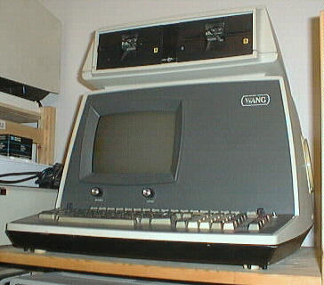

Perhaps the most significant feature was that this was the computer that the 5.25" floppy was invented for. Wang decided that 8" drives would be too cumbersome for this class of machine, so they contacted Shugart for development of the smaller drives and media.

The first page of the 2280 Disk Drive User Manual (700-5216A) makes reference to the PCS-III. Chris Cummings, an active member of the Wang community back then, describes the PCS-III this way:

The PCS III was basically a 32K PCS-II with a disk mux. It could talk to the 2230s and 2260s but not the Phoenix. I think the other options were the same (24x80, 2nd floppy, TC ports, etc).

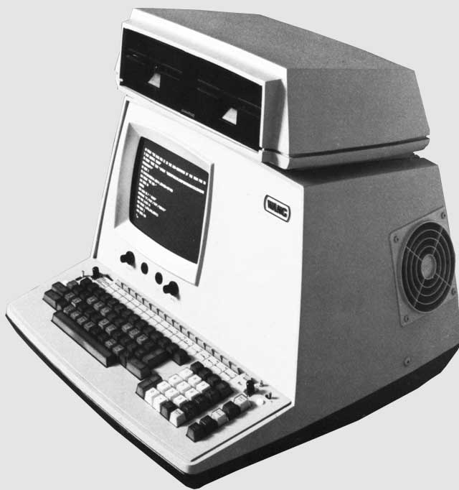

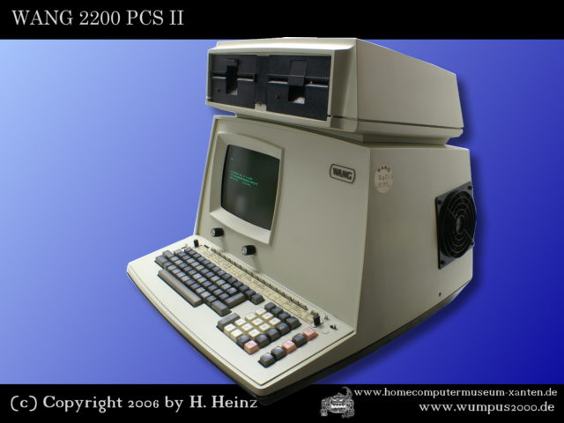

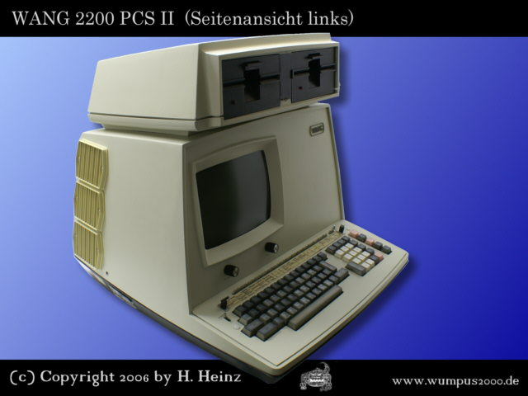



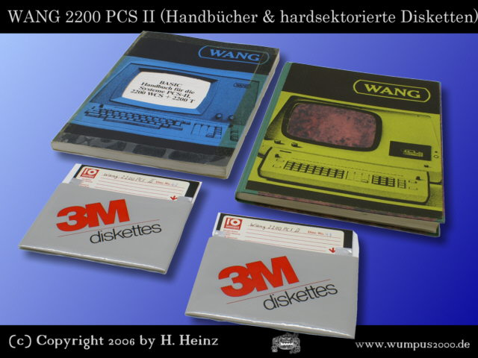

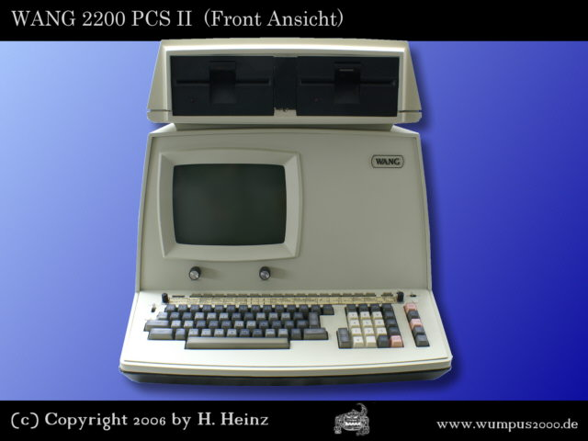

http://www.wang2200.org/  
http://www.gaby.de/wang.htm